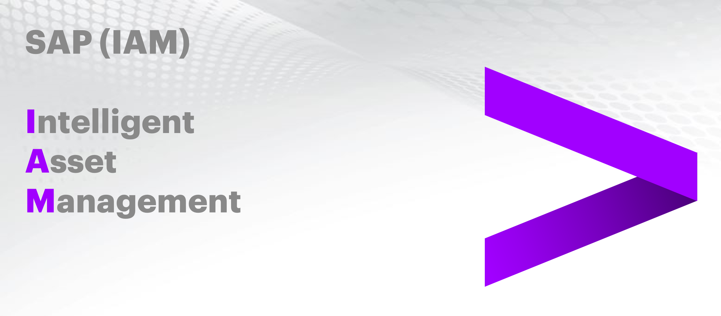

Equipment Creation Document

Document Control

Prepared by:
Version | Date | Name
1.0 | 01/21/2025 | ABHIJIT KUMAR
2.0

Reviewed by:
Version | Date | Name
1.0 | 01/22/2025 | NIKHIL KOOLWAL, SRINIVAS RAO PATHI, VIJAY PATIL

Reference Documents

The following section describes relevant documentation:
Document Name | Description | Sharepoint Link
Equipment Creation Document | Steps to create an Equipment | Equipment Creation Doc.docx

Contents
1.What does equipment creation mean? 4
1.1 Steps for equipment creation 4
1.2 Using SAP GUI 5
2. Equipment Hierarchy 11
2.1 Example: 11
2.2 Access the Equipment Master Record: 11
2.3 Steps to create Sub Equipment: 12
2.4 Steps to assign Superior Equipment: 13

1.What does equipment creation mean?

In SAP Plant Maintenance (SAP PM), equipment creation is the process of defining and registering a physical asset within the system. This asset could be a machine, a vehicle, a building, or any other tangible object that requires maintenance and management.

In SAP Plant Maintenance (SAP PM), equipment creation is the process of defining and registering a physical asset within the system. This asset could be a machine, a vehicle, a building, or any other tangible object that requires maintenance and management.

1.1 Steps for equipment creation

Login to SAP Fiori -https://awsast0685.enggsap.accenture.com:44300/sap/bc/ui2/flp?sap-client=100&sap-language=EN
Fiori dashboard is displayed and then click on create Equipment.
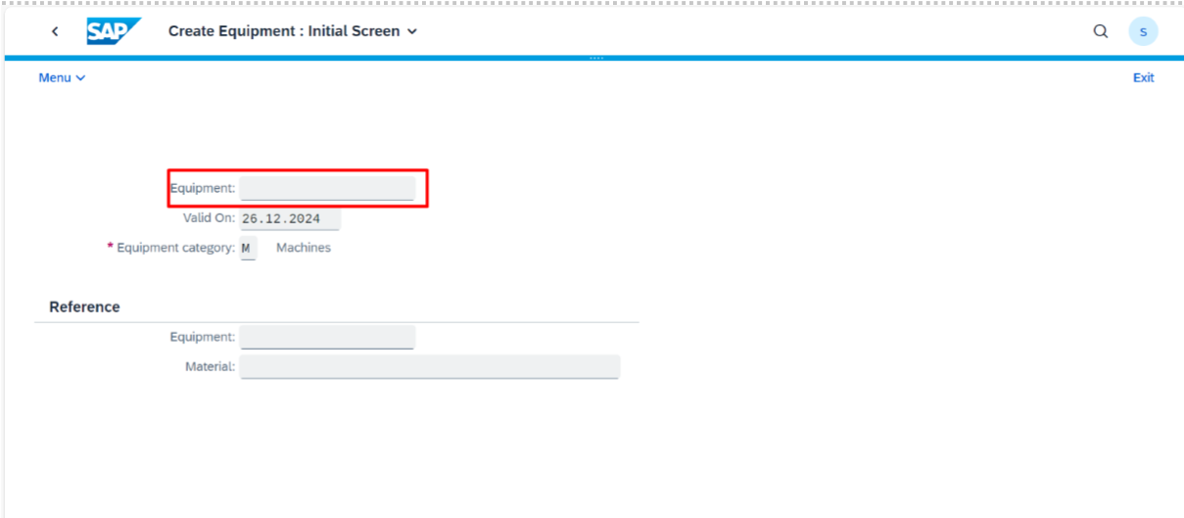
Equipment screen is opened.
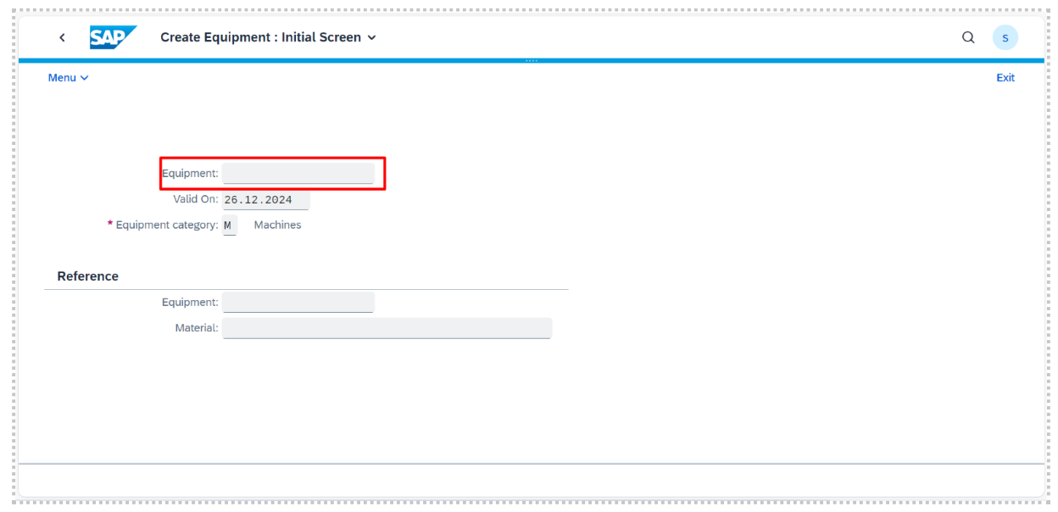
1.2 Using SAP GUI

Equipment can also be created through SAP GUI.
Below are the steps:
1. In the main menu, choose Logistics > Plant maintenance > Technical objects or use T code IE01.
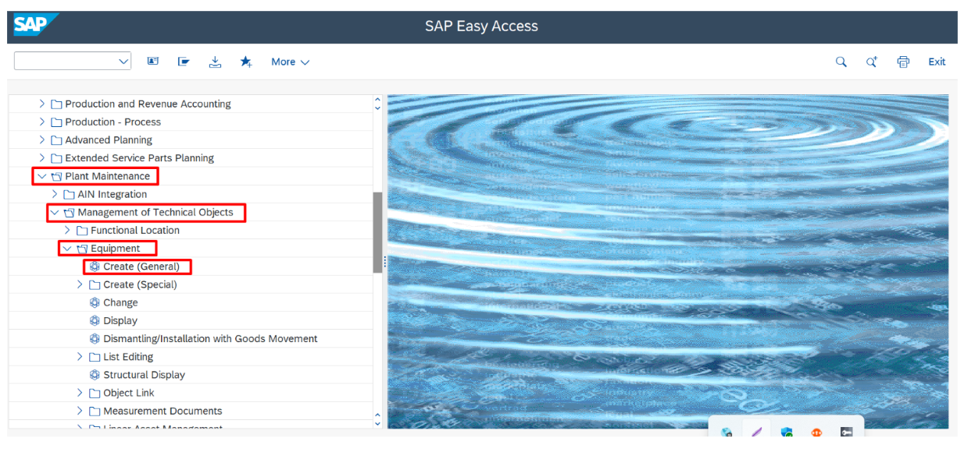

2. You reach the Technical Objects screen. Don’t give equipment number here. System will assign a number. Select Equipment category e.g. Machine and press enter.
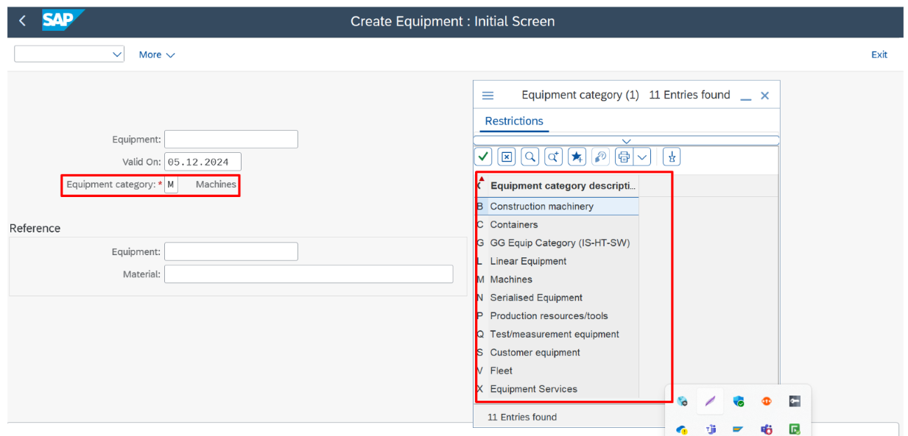
3. In General Tab
Give the Equipment startup date ad end date if required. Enter the required fields in reference data and manufacturer data and equipment description. In general data tab, enter the details such as object type, weight, size, dimension.
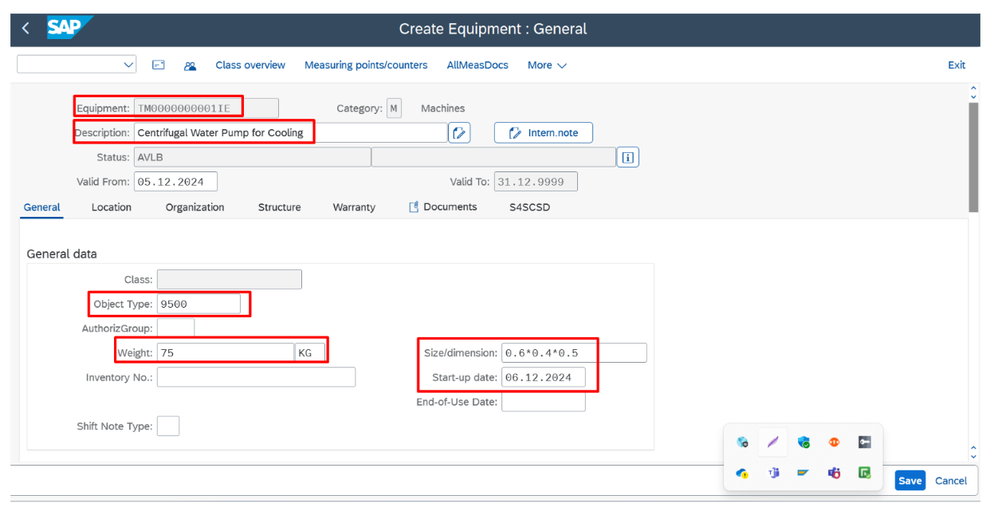
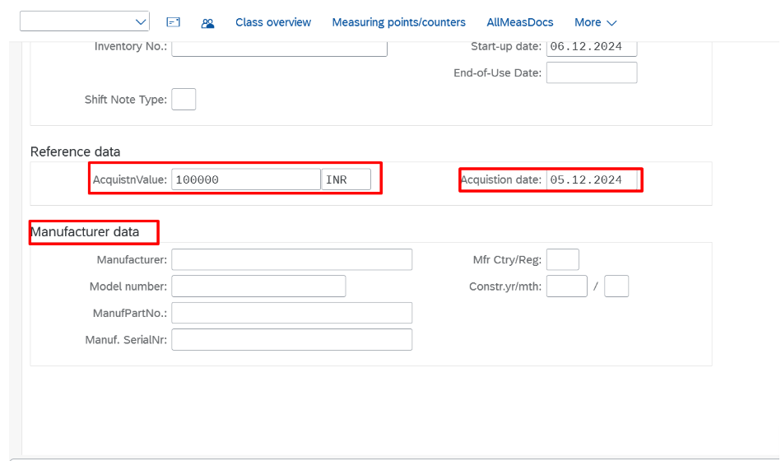

4. In location tab, enter MaintPlant required fields.
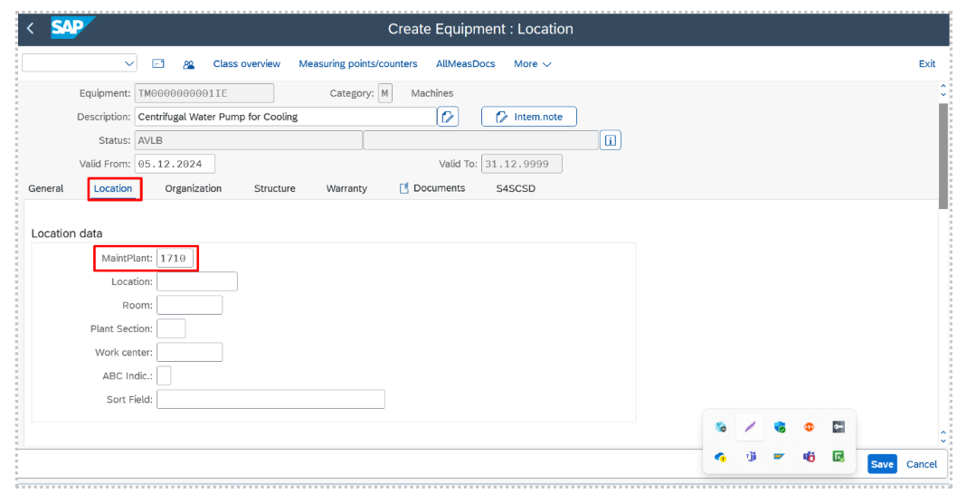
5. In organization tab enter the cost center, planning plant, planner group, work center.
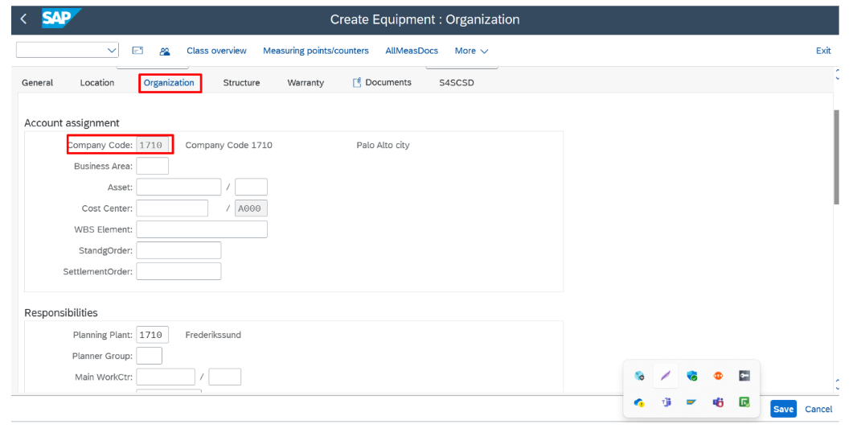

6. To install equipment at functional location in structure tab enter the functional location.
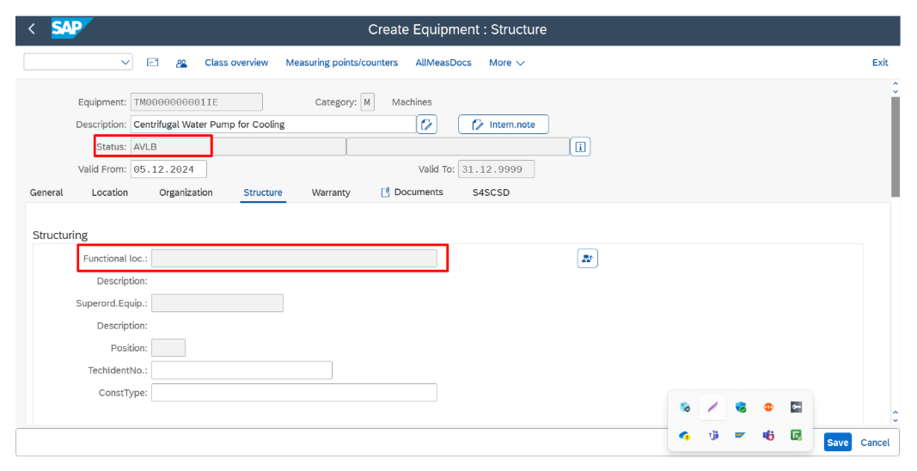

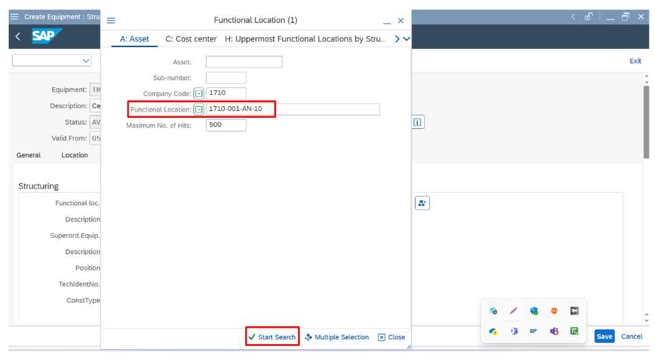

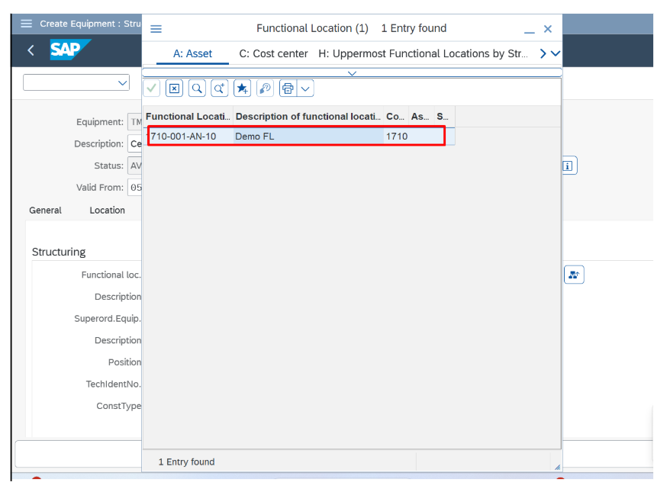

7. In warranty tab enter details if required then click on save.
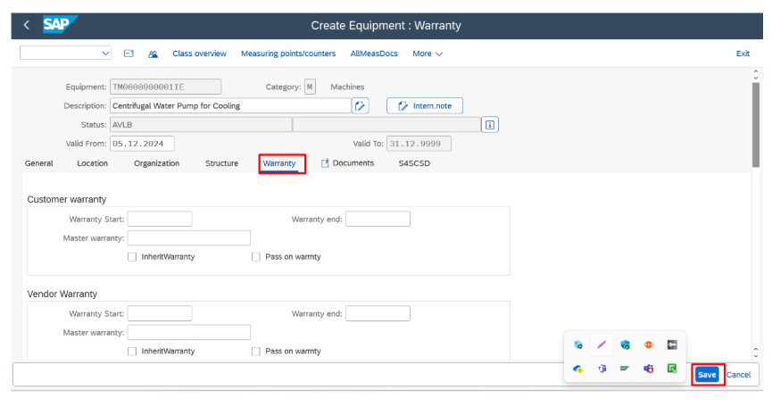
Equipment Number is created.
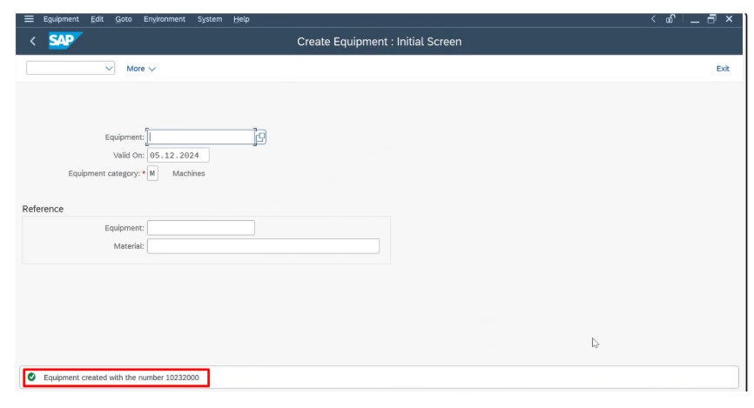
2. Equipment Hierarchy

In SAP Plant Maintenance (PM), an equipment hierarchy is a structured relationship between pieces of equipment. This hierarchy is used to represent and manage complex systems or machinery by linking related equipment in parent-child relationships.

- Superior Equipment (Parent Equipment):
- The superior equipment is the primary or "parent" equipment in the hierarchy.
- It represents the main machine, system, or higher-level component to which other equipment is physically or functionally connected.
- Sub-Equipment (Child Equipment):
- Sub-equipment is the child or dependent equipment linked to the superior equipment.
- It is considered part of or a component of the superior equipment. Sub-equipment can also have its own equipment master record, making it manageable separately.
2.1 Example:

- Superior Equipment: Air Conditioning System
- Sub-equipment:
- Compressor
- Condenser
- Fan
2.2 Access the Equipment Master Record:

- Open the SAP GUI.
- Go to transaction code IE02 (Change Equipment) or IE03 (Display Equipment) for an existing equipment record.
- Use IE01 (Create Equipment) if you are creating new equipment.

2.3 Steps to create Sub Equipment:

- 1.Go to IE01 to create equipment or IE02 to change Equipment.
- In structure tab, in Equipment field give the sub equipment numbers.
- click on save.

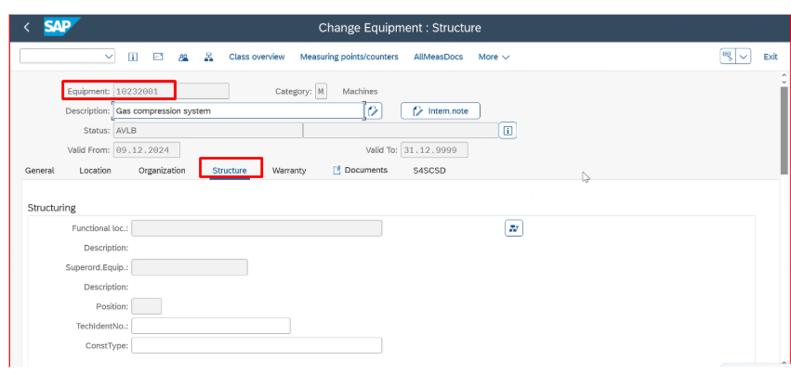

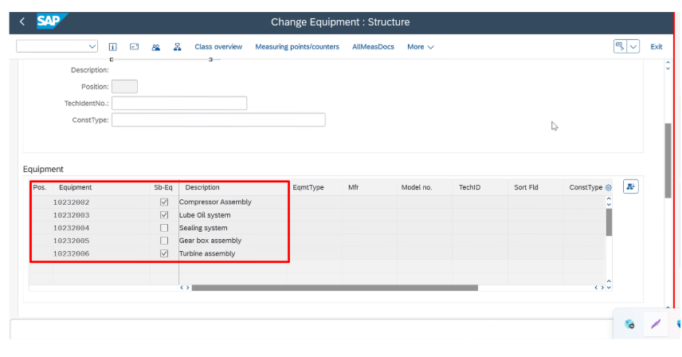
2.4 Steps to assign Superior Equipment:

1. In the equipment master record, navigate to the Structure tab.
2. Find the field labeled Superior Equipment or Superordinate Equipment.
3. Enter the equipment number of the parent (superior) equipment in this field.
4. save the changes.

